Dato: | Nov 6, 2019 9:24:49 AM
Type af måling: | Type 1 @ 300 meter
Kaliber: | DJF
LOT Nr.:
Udført af: | DK-BULLET

Resultat:

No. | x [mm] | y [mm] | V_T300.00 [m/s] | E_T [J] | Vo [m/s]
1 | -5.2 | -112.2 | 491.72 | 1253.67 | 821.34
2 | 12.8 | -82.8 | 500.07 | 1296.61 | 836.88
3 | -40.6 | -141.7 | 492.95 | 1259.94 | 824.07
4 | -25.2 | -67.1 | 491.95 | 1254.87 | 823.90
5 | 54.7 | -104.7 | 487.29 | 1231.20 | 815.62
6 | -10.7 | -80.3 | 483.25 | 1210.88 | 807.65
7 | 27.8 | 4.1 | 493.93 | 1264.96 | 826.29
8 | 11.9 | -89.9 | 487.11 | 1230.29 | 813.31
9 | -74.9 | -124.2 | 496.57 | 1278.52 | 830.52
10 | -126.1 | -131.0 | 496.00 | 1275.62 | 828.51
MEAN | -17.6 | -93.0 | 492.09 | 1255.66 | 822.81
MAX | 54.7 | 4.1 | 500.07 | 1296.61 | 836.88
MIN | -126.1 | -141.7 | 483.25 | 1210.88 | 807.65
RANGE | 180.9 | 145.9 | 16.82 | 85.73 | 29.23
STDEV | 52.6 | 41.7 | 5.05 | 25.72 | 8.68

Evaluation | Value[mm]
Impact Mean Point X | -17.6
Impact Mean Point Y | -93.0
Mean Radius | 54.1
Group Rectangle Width | 180.9
Group Rectangle Height | 145.9
Largest Distance | 204.9

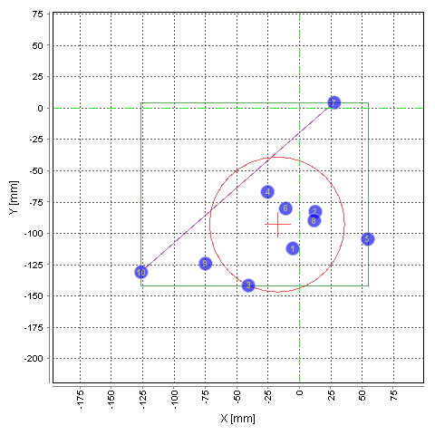
Accuracy pibe | DJF
Antal skud totalt til dato: | 429

